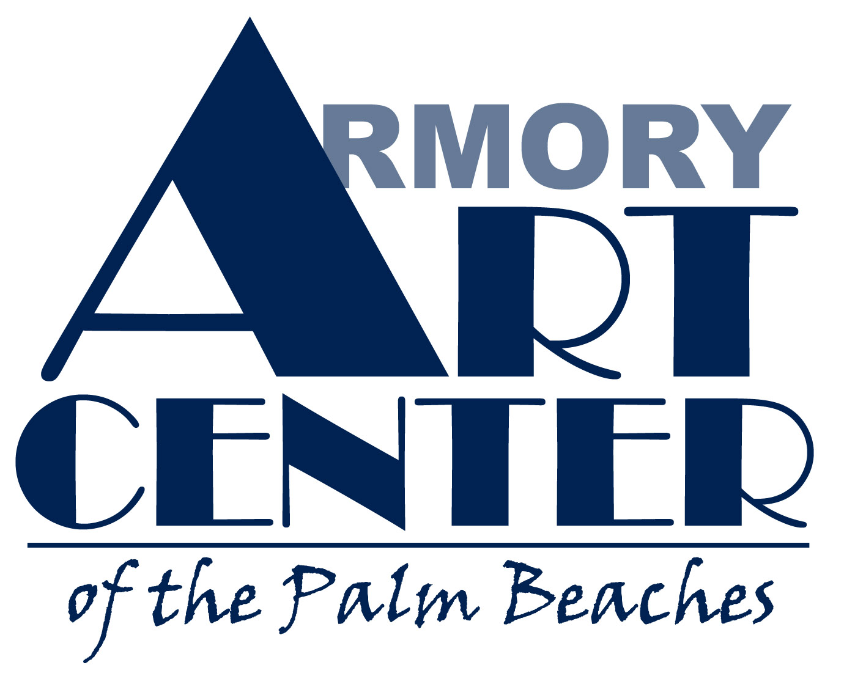

Jewelry/Metals/Glass

Artist-in-Residence Program & Visiting Artist Program

The Armory Art Center (AAC) is a not-for-profit community-based visual arts education and exhibition center providing opportunities for individual growth, self expression, increased awareness and appreciation of the arts through participation in studio art classes, exhibitions, lectures and other educational programs. The Center seeks to educate, enrich and engage a diverse population through the “experience of art”.

The Armory Art Center in Palm Beach County, Florida is seeking a recent or mature MFA graduate jewelry/metalsmith or fused glass artist for a residency position in the Jewelry/Metals/Glass Department. Responsibilities and stipend depend on term of residency, which can range from 8 months up to a year. Resident will be scheduled to teach up to three 3-hour classes a week. Exact classes will be determined by the Resident and Department Chair. Demonstrations during class are encouraged. Resident will give a lecture on their work and influences. Resident may give an additional workshop. On campus studio and monthly stipend provided. Resident group exhibition will be during year of residency.

Stipend will be $6,200.00 plus compensation for teaching classes.

The Armory’s Jewelry/Metals/Glass studios are over 1400 square feet and well equipped. Included are….
-3 glass fusing kilns
-wet grinders, belt sanders, etc.
-3 enameling kilns
-2 rolling mills
-20 ton hydraulic press
-English wheel
-pneumatic planishing hammer
-selection of raising and forming stakes
-2 metal shears (1 with rollers and metal break)
-all of the standard hand tools for metalsmithing and glass

Mission of Program:
The Armory Art Center’s Artists-in-Residence and Visiting Artist Program provides a supportive atmosphere for emerging and professional artists in a variety of studio areas and seeks to:

- Enhance the diversity and quality of the studio experiences that the AAC provides to its students and community
- Provide support of artists who wish to share their vision with the community in a specific manner
- Stimulate public participation with these artists and artistic processes in order to build appreciation for value of arts in daily life
- Enrich the community through interaction with artists and artwork that they would not otherwise experience in Palm Beach County

Program Administration:
The selection and scheduling of the AIR/VA Program will be under the direction and coordination of the Executive Director, Director of Programming and the Studio Department Chair. Once the program is established, the AIR/VA participant will report directly to the Studio Department Chair. Funding of each residency is dependent upon assistance through grants, sponsorships and donations.

Program Parameters:
- Each residency must be related to AAC’s programs.
- Artists involved in residencies may be of local, regional, national or international stature and be a U.S. Citizen or a U.S. Permanent Resident.
- During the period of a residency the artist will have use of the studio to use as their primary workplace. In addition to studio space, the artist will receive a monthly stipend for expenses depending on the scope and parameters of the residency. The artist will provide his/her own supplies for works in progress.
- Artists must agree to commit for the entire period of the proposed residency once accepted into the program. Failure to do so forfeits the use of studio space, AAC’s facilities any remaining stipend received by the artist from the AAC for the program.
- Each residency must include a significant element of visitor contact with the artist. Priority will be given to residencies which include opportunities for the public to actively engage in the work of the artist.
- Each artist must be available to the AAC for program assistance and to the public at specified periods throughout the residency.
- Artists will have the opportunity to teach classes in their studio area during the scope of the residency under separate compensation for this service.
- Artists are responsible for securing their own living arrangements and transportation during the residency period.

Artist-in-Residence Responsibilities:
- Artists will be responsible for keeping facilities and equipment clean for others’ use and undertake regular maintenance and organizational tasks necessary for upkeep and communal studio use (average of 10-20 hours a week).
- Artists will have regular communication with the chair of their studio department to assess progress of body of work.
- Artist should show a willingness to conduct demonstrations and/or participate in AAC programming.
- Artists will be responsible for maintaining the studio in a safe and reasonably tidy manner throughout the residency and will not make any alterations to the space without permission.
- Artists must leave the studio in the state in which the studio was found and remove all belongings at the end of the residency.

Application and Residency Timelines:

- Applications are due August 15, 2008.

Submit the following materials to the attention of your studio department of interest:
- Completed Application Form
- Resumé
- Artist Statement (no more than one page)
- 10 slides or digital images of work complete during last 2 years
- 3 References who are familiar with you and your work (name, address, email and phone number)
- Proposal/Action Plan for what you hope to accomplish during your residency (1-3 paragraphs)
- SASE for return of materials

Submit Materials to:

Joseph L. Brandom
Artist in Residence Program
Armory Art Center
1700 Parker Avenue
West Palm Beach, FL 33401

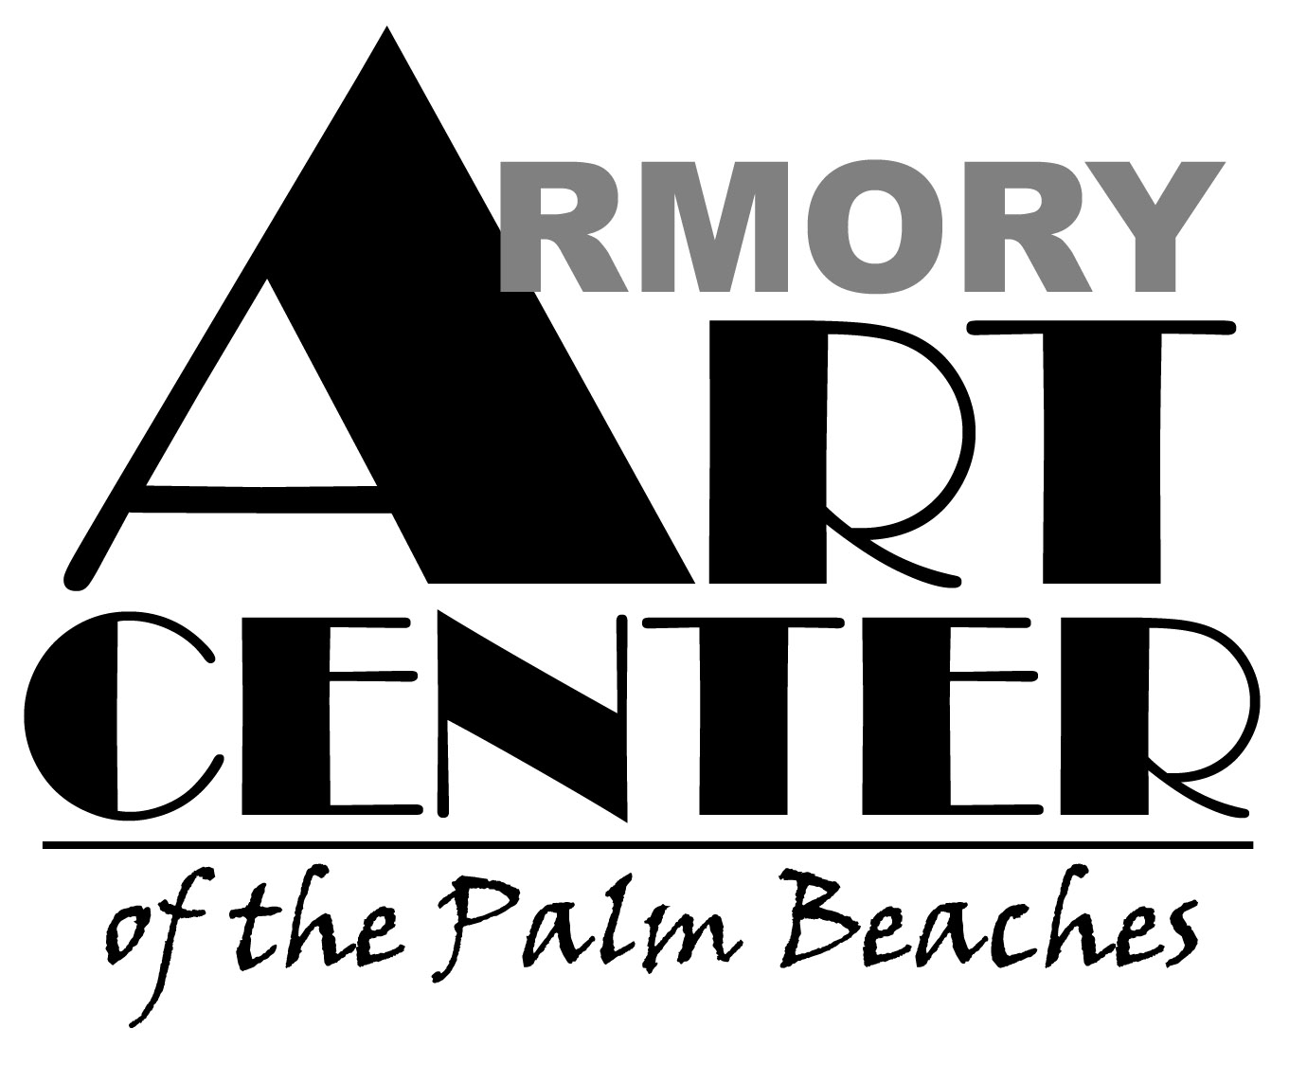
ARTIST- IN –RESIDENCE/VISITING ARTIST PROGRAM 2008-2009
APPLICATION FORM

The Armory Art Center’s Artists-in-Residence and Visiting Artist Program provides a supportive atmosphere for emerging and professional artists in a variety of studio areas and seeks to:
- Enhance the diversity and quality of the studio experiences that the AAC provides to its students and community
- Provide support of artists who wish to share their vision with the community in a specific manner
- Stimulate public participation with these artists and artistic processes in order to build appreciation for value of arts
- Enrich the community through interaction with artists and artwork that they would not otherwise experience in Palm Beach County

Artist Information
Name
Discipline/Area of Expertise
Address

Phone Fax
E-mail

Proposed Duration of Residency/Visiting Program (up to 12 months): ________ months
Application and Residency Timelines:
- Applications are due May 1, 2008 for residencies beginning August - October 2008 (will be notified in June)
- Applications are due July 1, 2008 for residencies beginning November 2008 - January 2009 (will be notified in September)

Submit the following materials to the attention of your studio department of interest:
- Completed Application Form
- Resumé
- Artist Statement (no more than one page)
- 10 slides or images of work complete during last 2 years
- 3 References who are familiar with you and your work (name, address, email and phone number)
- Proposal/Action Plan for what you hope to accomplish during your residency (1-3 paragraphs)
- SASE for return of materials

Submit Materials to:
Joseph Brandom, Jewelry/Metals/Sculpture Chair
Artist in Residence Program
Armory Art Center
1700 Parker Avenue
West Palm Beach, FL 33401

I attest that the information in this application and in the supporting materials is correct to the best of my knowledge.

Signature of Applicant Date Submitted

_____________
Signature of Department Chair Date Received

